SOFTWARE ENGINEERING

PROJECT

COLLEGE ADMISSION

PREDICTOR

SUBMITTED TO: SUBMITTED BY:

Ms. Shiwani Group-7 CML 4

DATA FLOW DIAGRAMS

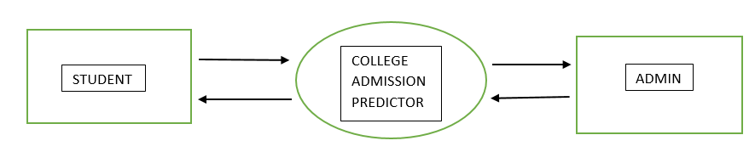

LEVEL 0 DIAGRAM

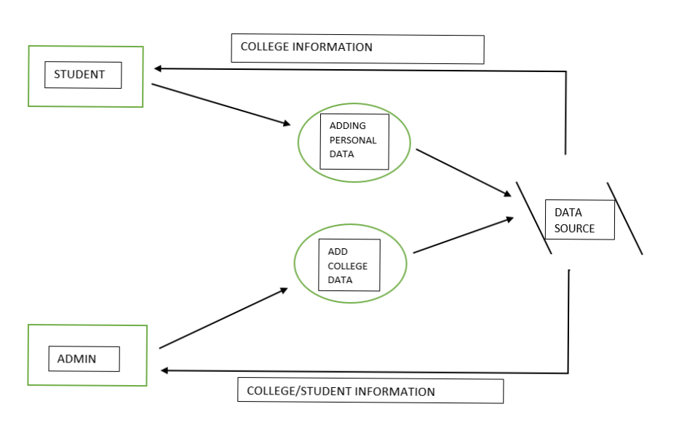

LEVEL 1 DIAGRAM

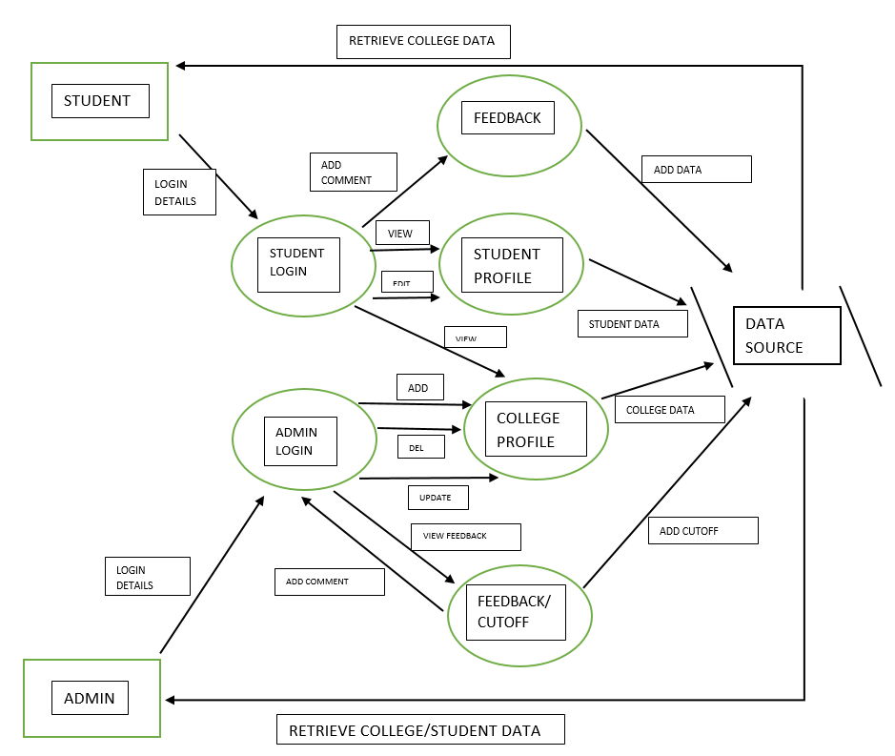

LEVEL 2 DIAGRAM